St Margaret’s Primary School- Respect for All Policy 2017-18

The purpose of this policy is to provide all stakeholders with a framework which offers guidance and strategy to promote equality and Respect for All.
It is our aim that everyone in our school community will work together in partnership to create a positive ethos in which bullying behaviour, regardless of type, is not accepted and where bullying will fail to thrive.
It is the responsibility of all pupils, staff and parents/carers to ensure that all members of our school community feel safe and valued and are able to build strong positive relationships which celebrate diversity, equality, equity and which encourage Respect for All.
By working together as a strong team, we will achieve this aim and our school vision.

St Margaret’s’ Primary Vision, Values & Aims.

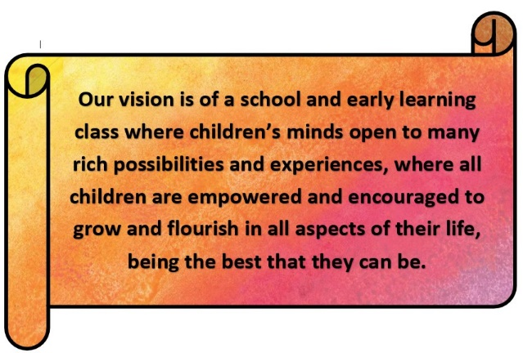
Our Vision | Our School Motto
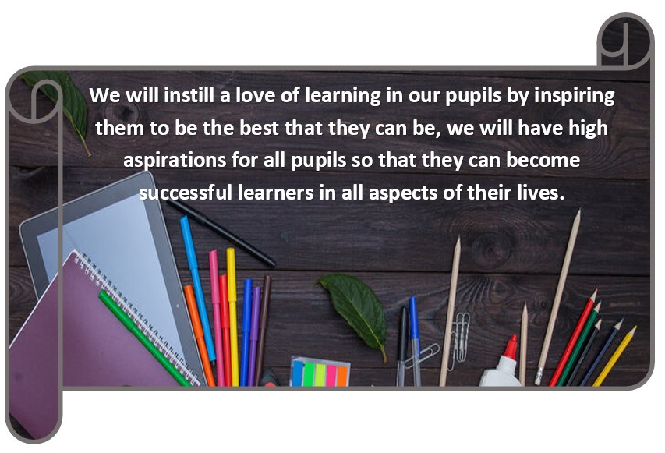
We Love God  I can do all things through him who strengthens me- Phillipians 4:13  For nothing will be impossible with God- Luke 1:37 | We Care for Creation  The heavens are yours, the earth is also yours, the world and all that is in it- Psalm 89:11
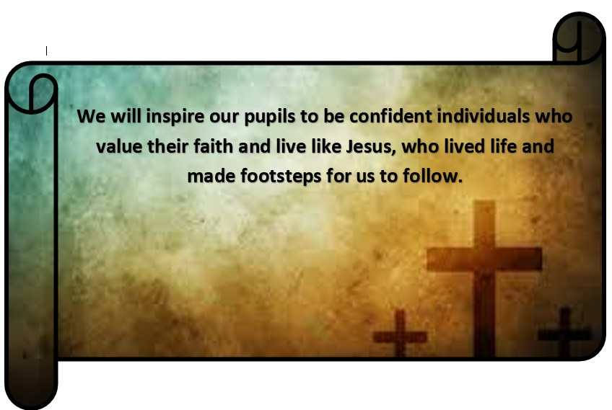 | 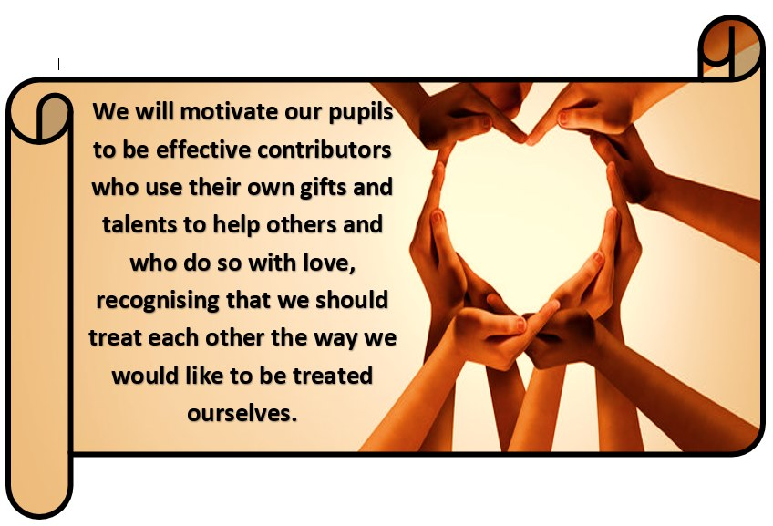
We Follow Jesus  For where two or three gather in my name, there am I with them- Matthew  18:20 | We Respect Others  Let all that you do be done in love- 1 Corinthians 16:14  As each has received a gift, use it to serve one another- Peter 4:10

In keeping with the national aim that all sectors and communities, at a local and national level, are consistently and coherently contributing to a holistic approach to anti-bullying, St Margaret’s Primary School community is committed to ensuring that:
• All our children are supported to develop respectful, responsible and confident relationships with other young people and adults
• Our young people are taught the skills and resilience to respond to and manage bullying behaviour appropriately
• All children and their parents/carers who require help with behaviour and/or relationships know who to contact and what support is available
• All adults working with our young people follow a consistent and coherent approach to managing and preventing bullying and in developing positive and nurturing relationships
• We create an ethos where bullying cannot thrive. As such, we encourage all pupils and the community to play an active part in the life of the school. We celebrate diversity and strive to create a shared understanding of what behaviour is acceptable and what is not.

Principles of our Policy
The principles of Respect for All within St Margaret’s Primary School are:
• We will promote and foster positive relationships and behaviours among all members of our school community
• We respect the rights of all children and young people as paramount (Children and Young People (Scotland) Act 2014)
• We will work together to maintain a culture of mutual respect and shared responsibility with all members of our school community
• We will implement highly effective and consistent practices to address and prevent bullying behaviour across all contexts of our school
• We will address and challenge all aspects of prejudice and discrimination to ensure that all types of prejudice-based bullying are managed equally (including bullying based on the protected characteristics as outlined in the Equality Act 2010)
• We will support effective communication, including sharing relevant and proportionate information, where appropriate, in accordance with the Data Protection Act 1998 and Human Rights Act 1998
• We will continue to understand and meet the needs of all our pupils and will support both those who experience bullying behaviour as well as those who display bullying behaviour within a framework of respect, responsibility, nurture and resolution
• We will continue to implement effective tracking and monitoring procedures to ensure that all children have their needs met in relation to the wellbeing indicators outlined in Getting It Right for Every Child and that all children are given the best opportunities to succeed and achieve
• We will share information where appropriate and work in partnership with parents/carers to ensure that our practice is transparent and cohesive
• We will continue to recognise and teach that bullying behaviour can have an adverse effect on personal development and will engage children across all stages in regular opportunities to develop their social and emotional wellbeing.
What do we mean by bullying?
Bullying is both behaviour and impact; the impact is on a person’s capacity to feel in control of themselves. This is what we term as their sense of ‘agency’. Bullying takes place in the context of relationships. It is behaviour that can make people feel hurt, threatened, frightened, left out and lack self-confidence. This behaviour happens face to face and online. (RespectMe, 2015)
Bullying behaviour can harm people physically or emotionally and, although the actual behaviour may not be repeated, the threat may be sustained over time, typically by actions, looks, messages, confrontations, physical interventions, or the fear of these.
Bullying behaviour can happen as a one-off incident or can be persistent.
Each incident requires to be investigated to establish whether the behaviour has been bullying, the impact the behaviour has had and what support is required for all children involved.
In line with ‘Respect for All’ and Renfrewshire Council’s Anti-bullying Policy, St Margaret’s Primary School recognises that not all disagreements between children and young people are necessarily bullying in nature and the need to consider both the behaviour and impact when investigating and resolving allegations of bullying behaviour.
Renfrewshire Council and St Margaret’s Primary School also recognise that labelling children and young people as ‘bullies’ or ‘victims’ can be disempowering and does not help to change behaviour or support recovery from being bullied.
Renfrewshire Council expects adults managing bullying to be able to distinguish between a person and their behaviour. It is also an expectation that all people, including those who are bullying, should always be treated with respect. Not labelling children helps to maintain the adult’s focus and response on the problematic behaviour.
Bullying behaviour can include:
• Being called names, teased, put down or threatened face to face/online
• Being hit, tripped, pushed or kicked
• Having belongings taken or damaged
• Being ignored, left out or having rumours spread about you (face-to-face and/or online)
• Sending abusive messages, pictures or images on social media, online gaming platforms, mobile phone or other devices
• Behaviour which makes people feel like they are not in control of themselves or their lives or that they have lost their personal power or ‘sense of agency’ (face-to-face and/or online) • Being targeted because of who you are or who you are perceived to be (face to face and/or online)
Bullying behaviour may be a result of prejudice that relates to perceived or actual differences. This can lead to behaviour and language that could manifest into racism, sexism, homophobia, biphobia or transphobia or prejudice and discrimination towards disability or faith.
Prejudice-based bullying is when bullying behaviour is motivated by prejudice based on an individual’s actual or perceived identity; it can be based on characteristics unique to a member of our school community’s identity or circumstance. For example, prejudice arising from socio-economic background, their ability to learn, mental health or a pupil’s appearance. Online bullying, or ‘cyberbullying’ as it is often referred to on social networking sites and online gaming platforms will not be treated any differently from face-to-face bullying. A person can be called names, threatened, or have rumours spread about them and this can (like other behaviours) happen in person and online.
Developing a culture of trust and high expectations
It is important that our pupils are able to discuss how they feel and develop resilience to manage their relationships. We know that pupils will fall out and disagree with each other as they form and build relationships. This is a normal part of growing up and most young people have the ability to ‘bounce back’ from this type of behaviour. Early intervention and prevention through education and modelling positive behaviour and relationships are key elements to ensuring we get it right for all members of our school community. Indeed, it is important to share the message with children that it is okay not to be friends with everyone but that there is an expectation that we treat everyone with respect. Providing the children with many progressive experiences to learn about emotions and how to manage these positively, including the development of self-esteem and resilience, is a key aspect of our work in developing confident individuals who are ‘emotionally literate’. This work is done in many ways at St Margaret’s Primary including through our health and wellbeing curriculum, assemblies, PAThS programme, House Groups, and themed days.
We strive to develop very positive and trusting relationships with our pupils so that they are supported to communicate their feelings, ask for help when needed and report concerns or issues which enable us to respond and support children and families and resolve issues as timely as possible. Some strategies we use to enable pupils can share concerns are: a senior management presence at breakfast club and in the lunch hall, class teacher check ins, open door policy with SMT and I would like to say boxes.
We have high expectations of conduct from all members of our school community. Our school culture and ethos are based on mutual respect. Alongside the development of nurturing approaches, we actively seek to build positive relationships between pupils, staff and parents.
Responsibilities of Pupils
It is always the responsibility of all members of our school community to demonstrate Respect for All. In situations where pupils witness behaviour, which is not appropriate towards others, pupils are encouraged to challenge such behaviour by speaking out. It is important that pupils report bullying type behaviour immediately to any member of staff or key adult. In the first instance, this is usually a member of the support staff in the playground or their class teacher, however the Head Teacher and Depute Head Teacher are available every day for children to speak to if required. Children who are displaying bullying type behaviour and those who are subjected to such behaviour are encouraged and supported to take part in restorative work to ensure issues are resolved quickly and have no lasting impact. This work is supported by a member of the management team who, in partnership with the class teacher, support staff and parents/carers as appropriate, will monitor the impact of the work and take further action as necessary.

Responsibilities of Staff
It is the responsibility of all staff across the school to ensure that they understand and adhere to Renfrewshire Council’s and the school’s Anti-bullying policies.
As a nurturing school community, all members of staff are expected to model positive and respectful relationships with pupils, parents and staff. If staff witness or have an incident of bullying behaviour reported to them, they will deal with the situation immediately.
Staff should challenge all forms of bullying behaviour at the time of occurrence and use each situation as a learning opportunity.
All incidents will be reported to a member of the senior management team for recording and further action if appropriate. Teaching staff will take a lead role in supporting and teaching children to build and sustain positive relationships and to develop skills of resilience and problem solving as well as developing confidence and self-esteem.
In line with Renfrewshire Council’s Anti-bullying Policy, when responding to incidents or reports of bullying behaviour staff will consider:
• The nature of the behaviour
• The impact of the behaviour
• The desired outcome of the pupil
• The action required
• The attitudes, prejudices or other factors that influenced the behaviour
It is essential that there is trust between home and school to manage day to day incidents and that, where appropriate, parents are able to contact the school to discuss or share information that the school may not be aware of or that their child has reported to them. The school encourages parents to make contact to a member of the senior management team as early as possible so that we can work together to manage any concerns. Reports of alleged bullying made by parents/carers/others will be treated as bullying incidents and the school will aim to complete an investigation and implement any remedial action within 3 working days and communicate the outcome to the affected children and their parents.
In line with Renfrewshire Council guidelines, all incidents assessed as bullying will be recorded on SEEMIS, our electronic management of information system, within the Bullying & Equalities module.
Renfrewshire Council advises that staff should use their professional judgement when deciding what to record on SEEMIS. Not all disagreements between children are necessarily bullying and it is recommended that staff should consider behaviour and impact before deciding if it is bullying and whether it should be recorded. The purpose for recording is for schools to learn about what kind of bullying is happening in their establishment and to identify if there are trends or issues which require addressing. To this end, recording is an improvement tool.
Each incident recorded should include the following details:
• The children and young people involved including the adults
• The type of bullying experienced
• Any underlying prejudice, including details of protected characteristics
• The impact of the bullying incident
• Actions taken including resolution at an individual or organisational level
Pupils who are exhibiting bullying behaviour will be given help and support to:
• Identify the feelings and/or circumstances that led to the bullying behaviour and to take responsibility for their behaviour
• Develop alternative and more positive ways of responding to these feelings/circumstances and to make positive choices
• Understand the impact of their behaviour on other people
• Repair relationships as appropriate
Pupils who demonstrate bullying behaviour will be provided with clear expectations about their behaviour which will be shared with their parents as well as a range of appropriate ways to respond which will be shared with all key members of staff. This may include taking steps to repair a relationship which they will be given support to do if needed.
Planned opportunities will be put in place for pupils to learn from the experience so that they are able to change their behaviour moving forward and make positive choices in the longer term. Consideration will be given to any factors that may impact upon a pupil’s wellbeing, including additional support needs. Appropriate action, for those bullying and those experiencing bullying, will be discussed with the children involved, parents and staff to ensure transparency. The aim of all actions is to ensure the safety and wellbeing of the children involved and where possible to restore and/or develop respectful and positive relationships.
These actions may include:
• In-house systems such as restorative discussions
• Change of seat in classroom with enhanced supervision in class
• Enhanced playground supervision
• Home Link Worker input
Responsibilities of Parents/Carers
We encourage and actively promote positive home/school partnership working. We seek to foster trusting relationships with all our parents/carers built on mutual respect and honesty. We recognise that bullying behaviour can have a significant impact on a child’s wellbeing and would advise parents to report any concerns they may have as quickly as possible with a view to working together with the school to support their child.
We recognise the impact that bullying behaviour can have on parents/carers and on families and that experiencing such behaviour can be emotional and distressing. We will endeavour to be available to meet with or speak to parents in a timely fashion. We also recognise that managing bullying behaviour and restoring relationships can take time and that this can be worrying and frustrating for parents. We will seek to involve all parents in the process, sharing information regularly on the progress of interventions and/or support. This may involve phone calls or meetings with parents to discuss actions taken by the school and the impact of these and will involve feedback from pupils, parents and staff.
Often bullying behaviour happens online. We strongly encourage parents/carers to monitor their child’s use of technology and ask them to challenge any negative usage as well as support their child if they are receiving bullying messages by ensuring social media accounts are private. Inappropriate online usage can be reported to Police Scotland by parents, however reporting misuse to the school is also helpful and will enable us to monitor and support the situation. We recommend that parents be added to their child’s site so that this can be always monitored. The school will offer parents online support workshops through agencies like NSPCC.
A Whole School Approach to Preventing Bullying
It is the responsibility of all members of our school community to tackle bullying. With this aim, St Margaret’s Primary School is committed to the following approaches:
• Developing a positive school culture and ethos based on clear values understood and shared by all
• Developing a nurturing ethos which is based on positive relationships among pupils and between pupils and staff where children feel safe, supported, and valued
• Participating in ongoing anti-bullying professional learning so that all members of staff have up to date knowledge and skills to manage and support bullying behaviour and the impact on children
• Promoting and teaching anti-bullying regularly through Assemblies, Health & Wellbeing Curriculum, Agency inputs and Mindfulness training.
• Supporting children to develop positive relationships, social skills, and emotional literacy
• Recognising and promoting Children’s Rights & Responsibilities through our Pupil Voice Groups, House Groups, Assemblies and Health & Wellbeing Curriculum
• Encouraging and practising nurture based and solution-focused approaches to managing behaviour and relationships where children are treated with dignity and respect and can reflect on and take responsibility for their behaviour with support
• Creating inclusive and supportive learning environments that meet the needs of all children • Promoting positive partnerships with parents and the community where all parents/carers feel welcomed, respected and valued and where parents and the school can work together in the best interests of all our children
• Encouraging positive behaviour in school, on school trips in the community and when travelling on school transport.
Pupils will be supported to make positive choices and staff will work with pupils and parents when required to ensure our nurturing message is clear and consistent.
Policy Creation and Review
This policy is designed to serve all members of the St Margaret’s Primary School Community and as a result pupils, parents and staff have been involved in the creation of this policy. We are aware that the nature of bullying type behaviour is ever evolving and that it is essential that our Respect for All policy is relevant and responsive to the needs of our school community. We are committed to reviewing and amending the policy, as necessary, on a three-yearly cycle.
Acknowledgments
This policy has, for the most part, been derived from guidance and information shared in Respect for All: The National Approach to Anti-bullying for Scotland’s Children and Young People 2017 and reflects the advice and guidance presented in Renfrewshire Council’s Anti-bullying Policy

Reviewed 2022 to reflect updated Vision, Values and Aims.

