School Handbook
2023-2024

Contents
Contents 1
Welcome from the Head Teacher 4
Our Values 5
School Aims 6
Service Pledges 6
Standards and expectations 6
About Our School 8
School staff 8
School Information 9
School day 9
School year 10
School in-service days 10
School dress 11
Registration and Enrolment 11
Induction procedures for pupils starting school and their parents 12
Class Organisation 12
Assessment and Reporting 12
Summary of the School Improvement Plan 12
School aims 12
Strategic Improvement priorities 12
Actions/Interventions 12
The Scottish Attainment Challenge 12
Transfer to Secondary School 13
Early Learning and Childcare Class of 13
Early Learning and Childcare Class Provision 13
Admission to Nursery 14
Transfer to Primary 14
Car parking 14
Care and welfare 14
School security 15
Attendance and absence 15
Bullying 15
Safeguarding including child protection 16
Mobile phones 16
School meals 17
School transport 17
Pick-up points 18
Placing requests 18
Assisted support needs 18
Playground Supervision 18
Pupils leaving school premises at breaks 18
Equalities 18
Medical and Health Care 19
Religious Observance 20
Managing positive behaviour 20
Wet weather arrangements 20
Curriculum Matters 21
School curriculum 21
Curriculum for Excellence 22
Getting it Right for Every Child (GIRFEC) 22
Additional Support for Learning 22
Inclusion 22
Support 22
Universal support 22
Targeted support 23
Educational Psychology Service 23
Health and Wellbeing Education 24
Specialist support service – teachers teaching in more than one school 24
Homework 25
Developing the Young Workforce 25
Extra Curricular Activities 26
Home School Community Links 27
Parental Involvement 27
Parent Teacher Association 28
Home School Links 28
Pupil Council 28
Community Links 28
School Lets 29
Other Useful Information 29
Listening to learn - complaints, comments and suggestions 29
Data Protection 30
Information in Emergencies 30
Important Contacts 31
Websites 32
Glossary 33
Parent feedback 34
Tell us what you think 35

Welcome from the Head Teacher

Buchanan Street
Johnstone
PA5 8RY
Tel: 03003000185
14 August 2023
Dear Parents
Welcome to St. Margaret’s.
I hope you will find this handbook interesting and useful. In it we have tried to give you a picture of life in St. Margaret’s.
I believe that together the staff, parents and pupils of St. Margaret’s have created a happy, caring, and respectful community where all the children are helped and encouraged to achieve their full potential. We have high expectations. of and for all the children and are rarely disappointed.
We try to prepare the children for the world they live in by helping them to develop emotionally, spiritually, and intellectually in the hope that they will be happy, well-adjusted members of society.
I am sure these are the same hopes you have for your child, and I look forward to working with you and your family in St. Margaret’s.
Yours sincerely
Gillian Miller
Head teacher
Contact: gillian.miller@renfrewshire.school

Our Values
More than 4,000 voices including our staff, residents, partners, young people and community groups helped identify the values most important to us all that describe our promise to our communities, staff and partners and what people can expect of us.
These values have been formally adopted by Renfrewshire Council and will guide how we deliver services and make decisions every day.
- We are fair. We treat each other and everyone we deal with respectfully and work hard to build trust in Renfrewshire Council
- We are helpful. We care about getting things right and are always approachable
- We are great collaborators. We work as one team and with people who care about this place
- We value learning to help us innovate, improve and deliver better services.

School Vision, Values and Aims
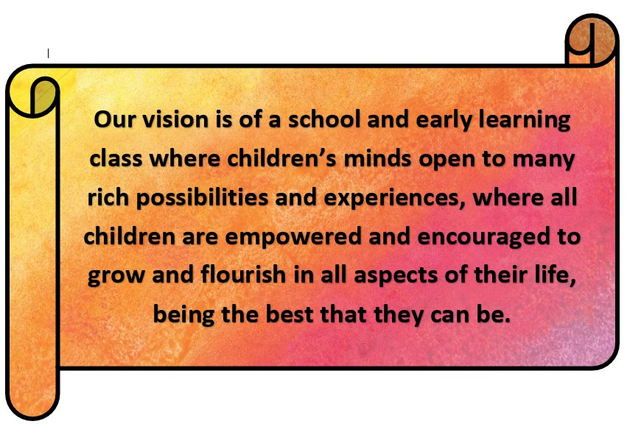
Our Vision | Our School Motto
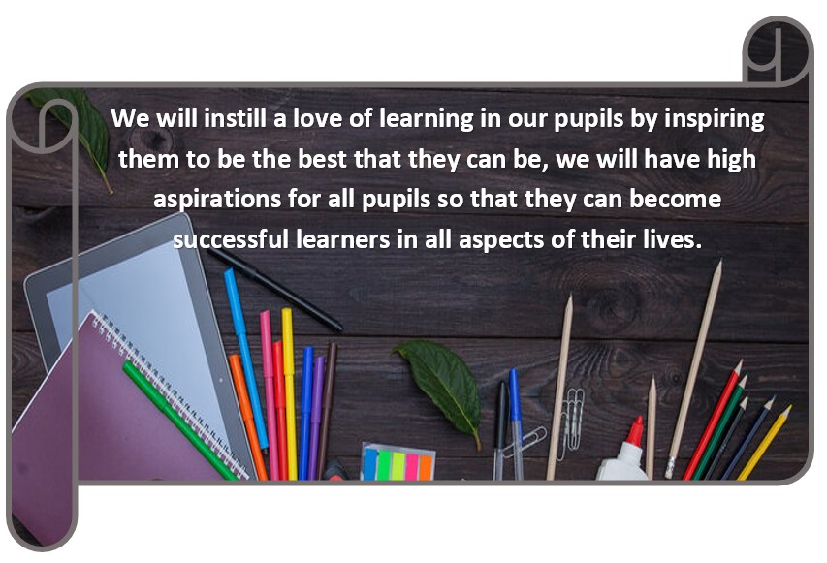
We Love God  I can do all things through him who strengthens me- Phillipians 4:13  For nothing will be impossible with God- Luke 1:37 | We Care for Creation  The heavens are yours, the earth is also yours, the world and all that is in it- Psalm 89:11
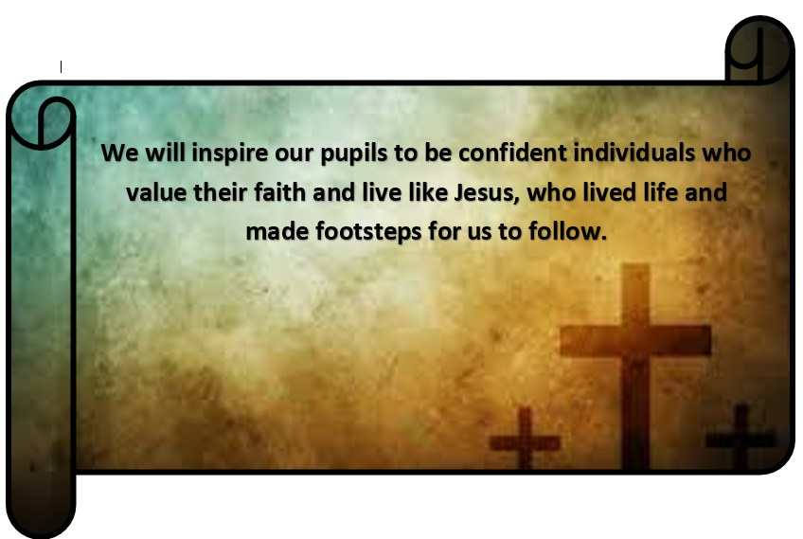 | 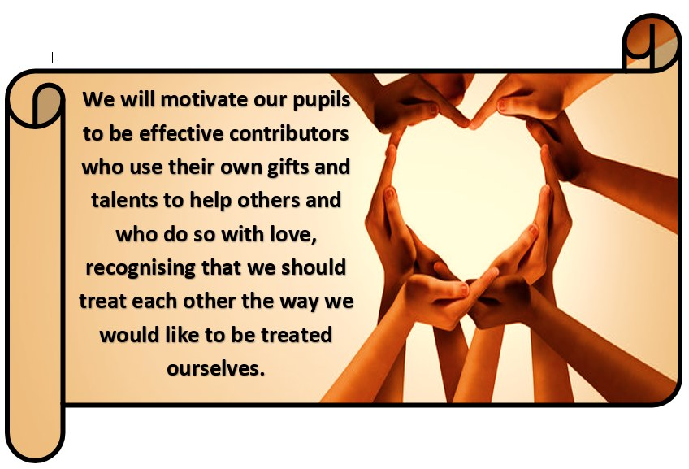
We Follow Jesus  For where two or three gather in my name, there am I with them- Matthew  18:20 | We Respect Others  Let all that you do be done in love- 1 Corinthians 16:14  As each has received a gift, use it to serve one another- Peter 4:10

Service Pledges

Standards and expectations
We will:
- offer all children and young people in our catchment area a free school place
- provide school premises which meet health and safety standards
- provide information on your child’s progress
- provide religious and moral education for your child
- give support and encouragement for parents to be involved in school life
- provide regular information on school activities
- provide 25 hours of class contact time in each normal school week for pupils of primary-school age

Pupils will have opportunities for:
- personal and social development
- music, cultural activities and creativity
- access to healthier lifestyles and sports activities
- community involvement

You can also expect us to:
- provide formal written reports on your child’s progress
- provide an annual report on school progress within our Standards and Quality Report
- give you an opportunity to have a formal meeting with your child’s class teacher
- strive to meet your child‘s needs

How can you help?
By law, you must make sure your child receives an education.
As a parent/carer, you can help your child by:
- making sure your child goes to school regularly
- encouraging and supporting your child with any homework/home study given
- encouraging your child to respect the school and the whole school community
- being involved in the school

The Education (Scotland) Act 1980 uses the broadly framed definition of ‘parent’. This is as follows:

“Parent” includes guardian and any person who is liable to maintain or has parental responsibilities (within the meaning of section (13) of the Children (Scotland) Act 1995) in relation to, or has care of a child or young person.

This is a wide definition which might, by way of example, include:

- non-resident parents who are liable to maintain or have parental responsibilities in respect of a child
- carers who can be parents
- others with parental responsibilities, e.g. foster carers, relatives and friends who are caring for children and young people under supervision arrangements
- close relatives, such as siblings or grandparents caring for children who are not looked after or are under home supervision arrangements

Everyone who is a parent, as defined in terms of the 1980 Act, has rights under the Act. This includes the right to receive advice and information about their child’s education, general information about the school, to be told about meetings involving their child, and to participate in activities, such as taking part in decisions relating to a Parent Council. Education authorities and schools should treat parents equally, the exception to this general requirement being where there is a court order limiting an individual’s exercise of parental rights and responsibilities. It is for education authorities to advise schools on the application of these rights in individual cases.

About Our School

School staff
Head Teacher and Depute Head Teacher
Head Teacher | Mrs Gillian Miller | Depute Head Teacher | Mrs Moira Hepburn
Teaching Staff
Mrs Heather Moynihan- Principal Teacher | Mrs Ann Johnston
Mrs Joanne Bruce | Mrs Emma MacIsaac
Miss Lucy Elder | Mrs Eileen McMahon
Mrs Mary Orr | Mrs Pauline Hughes
Mrs Claire Rankin | Miss Anne Gordon
Mrs Caroline Varendonck | Miss Suzy MacFadyen
Other staff in the school
Service Development Officer  Senior Clerical Officers  Classroom Assistants  Additional Support Needs Assistant  Instrumental Teachers  Senior Facilities Operatives  School Chaplain | Mr Paul Slaven  Miss Fiona Grant & Mrs Carol Reilly  Mrs Nicola Healy  Mrs Monica Holmes  Mrs Pearl Morris  Ms Martine Johnston  Mr Michael McMahon  Mrs Joanne Thomson (Violin)  Ms Caitlin MacDonald (Chanter)  Mrs Yvonne Kilcoyne & Mr Colin McGeoch  Fr Paul Brady

School Information

School contact details
Write to us or visit at:
St. Margaret’s Primary School
Buchanan Street
Johnstone
PA5 8RY
Telephone No. 03003000185
Email: stmargaretsenquiries@renfrewshire.gov.uk

Parent Council contact details
All enquiries for the parent council can be directed through the parent council email address: ptcstmargarets@gmail.com. Or via their Facebook Page: St.Margaret's PTC. Contact details for the Parent Council can also be found on a poster in the school entrance hall.

School day

School roll

The school roll in St. Margaret’s for 2023-24 is 168. The capacity of the school is 320.
Parents should note that the working capacity for the school may vary dependent upon the number of pupils at each stage and the way in which the classes are organised.
This school covers stages Primary 1 to Primary 7
Pupils are normally allocated to classes on the basis of age. When a composite class is formed pupils who are working at the same level are grouped together.
St. Margaret’s is a Catholic primary school. The school is co-educational, taking both boys and girls.

School day
School Opens  Morning Breaks  Lunch Breaks  School Closes | 9.00 am.  10.30-10.45am  12.15 to 1.00pm  3.00p.m

Primary 1 pupils attend school on a full-time basis from the start of the school year.

School year
First Term | Return date for Teachers | Monday 14 August 2023 (IS)
 | In-service Day | Tuesday 15 August 2023 (IS)
 | Schools re-open | Wednesday 16 August 2023
 | September Weekend | Friday 22 September 2023 and Monday 25 September 2023 (inclusive)
 | Schools re-open | Tuesday 26 September 2023
 | October holiday (schools closed) | Monday 16 October 2023 to Friday 20 October 2023 (inclusive)
 | Return date for Teachers | Monday 23 October 2023 (IS)
 | Schools re-open | Tuesday 24 October 2023
 | St Andrew's Day | Thursday 30 November 2023
 | Schools re-open | Friday 1 December 2023
 | Last day of session | Friday 22 December 2023
 | Christmas / New Year  Schools closed | Monday 25 December 2023 to Friday 05 January 2024 (inclusive)
Second Term | Schools re-open | Monday 08 January 2024
 | Mid-term break | Monday 12 February 2024 to Tuesday 13 February 2024 (inclusive)
 | Return date for Teachers | Wednesday 14 February 2024 (IS)
 | Schools re-open | Thursday 15 February 2024
 | Spring Holiday  Schools closed | Friday 29 March 2024 to Friday 12 April 2024 (inclusive)
Third Term | Schools re-open | Monday 15 April 2024
 | In-service Day | Thursday 02 May 2024 (IS)
 | May Day | Monday 06 May 2024
 | Schools re-open | Tuesday 07 May 2024
 | Local holiday (schools closed) | Friday 24 May 2024 and Monday 27 May 2024 (inclusive)
 | Schools re-open | Tuesday 28 May 2024
 | Last day of session | Thursday 27 June 2024

Teachers return Wednesday 14 August 2024

School in-service days
- Monday 14 August 2023
- Tuesday 15 August 2023
- Monday 23 October 2023
- Wednesday 14 February 2024
- Thursday 02 May 2024

School dress
Renfrewshire Council encourages each school to adopt a dress code and for any proposed changes to be discussed with parents, pupils and the parent council. The council supports an agreed dress code because of the benefits it brings, including improvements in safety, security, discipline, ethos and community spirit, and a decrease in bullying and expense for parents.
Some types of clothing will not be allowed in school for reasons of safety, decency or indiscipline. Types of clothing which will not be allowed include:
- clothes which are a health or safety risk
- clothes which may damage the school building
- clothes which may provoke other pupils
- clothes which are offensive or indecent
- clothes which encourage the use of alcohol or tobacco, or other inappropriate substances
Pupils will not be deprived of education, any benefit or access to examinations because of not wearing school uniform.
In the interests of health and safety, of both individual and others present, all jewellery, including body jewellery, must be removed before taking part in physical education lessons or physical activities. This includes watches, rings, chains and belts with metal buckles and other body jewellery and must all be removed before the physical education lesson, as these may cause injury to the wearer and others.

It is preferred that parents are advised that any child having body jewellery piercing wait until the summer break to allow them time to heal. However, parents wishing children to wear body jewellery during physical education should write to the school expressing their request. Children will be expected to provide tape and cover any such items of jewellery during the activity. Pupils will be responsible for the safekeeping of jewellery.
Grants for footwear and clothing for children are available to parents receiving certain benefits. Please see the council’s website: http://www.renfrewshire.gov.uk/Freeschoolmealsandclothinggrants
Information and application forms for free school meals are available from schools, registration offices and customer service centres. A form can be downloaded from the council's website: http://www.renfrewshire.gov.uk/Freeschoolmealsandclothinggrants
Please help the school and the education authority by making sure that pupils do not bring valuable or expensive items of clothing to school. The council has no insurance to cover the loss of valuable items.

St. Margaret’s Primary School dress code is:
- Burgundy/Grey sweatshirt, cardigan or tank top
- Grey trousers, skirt or pinafore
- White/Burgundy polo shirt or White shirt/blouse
- School Tie
All clothing should be marked clearly with the child’s name.
Polo shirt, shorts and sandshoes are required for PE lessons. Please note NO jewellery or football colours are permitted to be worn during PE lessons.

Registration and Enrolment
[schools to add to council statement]
The date for registration of new school entrants is advertised in all local nurseries, national and local press and on the council’s website www.renfrewshire.gov.uk. It is normally in November each year. Pupils should be registered in only one school for their catchment area. Parents will be provided with information about the school when they register their child.
Parents who want to send their child to a school other than the catchment school must make a placing request. Information on how to make a placing request is contained in the leaflet ‘Sending your child to school.’ The leaflet is available from any school, by phoning our customer contact centre on 0300 300 0300, or on our website www.renfrewshire.gov.uk. It is important to note that a successful placing request into a primary school does not guarantee a successful placing request when a child is transferring to secondary school.
Parents of pupils who have moved into the catchment area or, who wish their child to transfer to the school, should contact the school office for information.

Induction procedures for pupils starting school and their parents
Parents will be advised of parent meetings and pupil induction days during the spring and summer terms. There are generally 2 induction afternoons in the summer term where parents are expected to accompany their child to school. During these afternoons, the children will meet their teacher and new classmates and enjoy some activities in the classroom. There is also a ‘Come Play with Me’ day where the children can meet and play with their new classmates.
Parents are invited to participate in a school tour and information is given pertinent to the first few weeks of school life.

Class Organisation
St. Margaret’s is a co-educational primary school catering for both boys and girls. It meets the needs of the Roman Catholic community in the area it serves.
The present maximum class size at the Primary 1 and 2 stages is 25.
The maximum class size at the Primary 3 stage is 30.
From Primary 4-7 the maximum class size is 33 pupils.
Primaries 1, 2 and 3 are taught together by a team of staff in a play environment. They have 3 learning zones that they can visit each day- The Nest, The Den and The Magic Garden. Direct teaching takes place in our Transformation Station. All staff in P1, P2 and P3 have responsibility for the planning and delivery of education for all pupils. This is led by our Principal Teacher, Mrs Moynihan.

Assessment and Reporting
Assessment is an integral part of learning and teaching. It helps provide a picture of the learner’s progress and achievements and identifies the next steps in learning.
Assessment includes supporting learning, learner engagement and ensuring appropriate support.
Tracking learners’ progress
Information on learners’ progress is gathered through planned assessments and this information is recorded. This allows teachers to have a clear picture of how learners are progressing. It will also allow teachers to identify next steps in learning and inform reporting on progress and achievement.

Reporting
Regular reports to parents provide clear, positive, and constructive information about their child’s learning and progress, reflecting on what has been achieved against standards and expectations. Due to Covid mitigations teachers have endeavoured to contact parents via telephone and we have used digital technologies to share the work of the school.
Additionally, we use other methods of reporting to parents such as curricular exhibitions, programme of assemblies and come share my learning days.

Summary of the School Improvement Plan
St Margaret’s School Improvement Plan and Standards and Qualities Report are published annually on the school website.

http://www.st-margarets.renfrewshire.sch.uk/
Standards and Qualities Report 22-23
St Margaret's Primary School & Early Learning & Childcare Class
June 2023
Go to this Sway

The Scottish Attainment Challenge
Attainment Challenge and Pupil Equity Funding (PEF)
The Scottish Attainment Challenge, launched in 2015, is about achieving equity in education. This can be achieved by ensuring every child has the same opportunity to succeed. Renfrewshire is one of nine ‘challenge authorities’ who have received funding to improve literacy and numeracy and health and wellbeing, with a particular focus on closing the poverty-related attainment gap.
The Pupil Equity Fund (PEF) is being provided as part of the Attainment Scotland Fund. The PEF is allocated directly to schools and targeted at closing the poverty related attainment gap. Every council area is benefitting from the fund and is based on the number of pupils in P1-S3 known to be eligible for free school meals. The funding is to be spent at the discretion of the head teacher working in partnership with parents, pupils and staff to devise plans which focus on closing the poverty-related attainment gap.

Transfer to Secondary School
Pupils normally transfer to secondary school between eleven and a half and twelve and a half years of age, so that they will have the opportunity to complete at least four years of secondary education. Parents will be informed of the arrangements no later than December of the year before the date of transfer.
Parents who want to send their child to a school other than the catchment school must make a placing request. Information on how to make a placing request is contained in the leaflet ‘Sending your child to school.’ It is important to note that a successful placing request into a primary school does not guarantee a successful placing request when a child is transferring to secondary school.
St Margaret’s Primary School is an associated primary school of St Benedict’s High School.
Head teacher: Alan Taylor Telephone: 03003001441
https://www.oraetlabora.co.uk/

Early Learning and Childcare Class of St Margaret’s Primary School

Early Learning and Childcare Class Provision
The school's early learning and childcare class provides 64 places for children aged 3 - 5 years and 15 places for eligible children aged 2 years. (Not all classes have 2 year olds). Children are entitled to 1140 hours of early learning and childcare per year.
Children are eligible for entry to the nursery after their third birthday (dependent on their month of birth). Starting dates for children born on or between 1 March to 31 August will start Autumn term (August). If your child was born outwith these dates then they would start the month after their third birthday, e.g. child born on or between 1 to 30 September would start in October.
Some children aged two years are eligible for a funded place if their parent is in receipt of qualifying benefits. They are eligible to start from the term after their second birthday:
Term 1 - children born March to August will be eligible from August term that year.
Term 2 - children born September to December will be eligible from January following their birthday.
Term 3 - children born January and February will be eligible from April following their birthday.
To see if your child is eligible, please contact the school for further information or on the Council website https://www.renfrewshire.gov.uk/article/11142/How-much-free-nursery-hours-or-childcare-you-can-get
Application forms for an early learning and childcare place are available on the Council website https://www.renfrewshire.gov.uk/article/9741/Apply-for-a-free-nursery-or-childcare-place

Admission to Nursery
Early learning and childcare provision is non-denominational. Placement in the early learning and childcare class does not guarantee a place in the primary school if a placing request is necessary. All Renfrewshire early learning and childcare classes adhere to the council’s admission policy and all applications are dealt with in line with its guidelines.
The head teacher is a member of the local admissions panel which is made up of [nearby nursery classes, nursery schools and partnership nurseries - state whichever is applicable]. All applications are discussed at a meeting of this panel and agreement about the allocation of places is made by the members. Parents will receive notification when their child is allocated a place and information will accompany this about starting dates and times.
Normally children will start at the appropriate time in the term after their third birthday. In some circumstances children may be eligible for a place after their second birthday.

Transfer to Primary
Before leaving their early learning and childcare class, a transfer of information record for each child will be prepared by staff to ensure a smooth transition and continuity of education for the child transferring to primary.

Car parking
There is a small car park suitable for staff. The roads around the school get very busy at the start and end of the day, therefore, we would recommend a park and stride approach where possible to minimise risk and encourage good walking habits.

Care and welfare
Your child’s welfare is central to the ethos of the school. Please contact the school to share any concerns you have about your child’s welfare or wellbeing. The staff will work with you as parents to make sure children are safe, happy and able to benefit from the educational opportunities we offer.

School security
Renfrewshire Council has introduced procedures to ensure the safety and security of pupils and staff when attending or working in a school. We use a number of security measures including a visitors’ sign in book, badges and escorts, while visitors are within the school building. Normally, anyone visiting a school for any reason, will be asked to report to the school office. The school staff can then make the necessary arrangements for the visit.

Attendance and absence
It is the responsibility of parents of a child of school age to make sure that their child is educated. Attendance is recorded twice a day, morning and afternoon.
Please let the school know by letter or phone if your child is likely to be absent for some time and provide your child with a note on his or her return to school, confirming the reason for absence. If there is no explanation provided from a child’s parents, the absence will be regarded as unauthorised.
Please make every effort to avoid family holidays during term time as this disrupts your child’s education and reduces learning time. The head teacher can approve absence from school for a family holiday in certain extraordinary situations. Please discuss your plans with the head teacher before the holiday. Absence approved by the head teacher on this basis is regarded as authorised absence. If the head teacher does not give permission before the holiday, it will be recorded as unauthorised absence.
Parents from minority ethnic religious communities may request that their children be permitted to be absent from school to celebrate recognised religious events. Absence approved by the head teacher on this basis is regarded as authorised absence. Extended leave can also be granted on request for families returning to their country of origin for cultural or care reasons.
A supportive approach is taken to unexplained absence. The education authority, however, has legal powers to write to, interview or prosecute parents, or refer pupils to the Reporter to the Children’s Panel, if necessary.

Bullying
We strive to ensure St Margaret’s Primary School is an environment where bullying cannot thrive. We recognise that, at times, bullying may take place. We use local and national guidance when investigating and dealing with incidences of bullying.
Renfrewshire Council has an anti-bullying policy which was developed in consultation with pupils, parents and staff. The policy provides guidance on the prevention, identification and management of bullying – both the bullying behaviour and the impact it has.
Our school also has its own anti-bullying policy which sets out our local approach to tackling bullying. You can request a copy of the Council’s policy and/or the school’s policy from the school office or access them online at http://www.renfrewshire.gov.uk/article/3469/Antibullying
If you have a specific concern about bullying, please report this to the school so that we can investigate and take any action that might be needed.

Safeguarding including child protection
All children have a right to be protected from harm, abuse and neglect. The vision of the Renfrewshire Child Protection Committee is that “it’s everyone's job to make sure that children in Renfrewshire are safe."
Renfrewshire Council has a child protection policy and guidelines in place to make sure that all staff receive training each year and are confident in responding to any child protection or safeguarding issue, including e-safeguarding, child sexual exploitation and radicalisation. Staff ensure the wellbeing of children they come into contact with and work closely with other agencies to protect children and keep them safe. All school staff must report any concerns they have about the welfare of children to the school’s child protection co-ordinator.

Mobile phones
The benefits of mobile phones are recognised. Many young people and their parents regard them as an essential means of communication. Mobile phones can continue to be brought into schools, however the following limitations will apply in Renfrewshire schools.
- All phones should be turned off and kept out of sight during the school day within the school campus
- Photographing or recording of sound or images of staff, other pupils or visitors to the school is not allowed at any time within the school campus or on school transport
- Mobile phones may be confiscated where these rules are broken
- Any recordings made on school premises or school transport found on confiscated phones must be deleted on their return
- Any photographs or recordings of staff in any situation, whether taken on school premises or elsewhere, found on confiscated phones must be deleted from phones on their return
- Children’s Services expects that schools will, through normal collegiate procedures, develop or review existing policies on the use of mobiles phones that take account of the views of all staff, parents and pupils
- Schools should ensure that pupils, parents and staff are aware that should a pupil breach the policy, there will be consequences in line with the school’s positive behaviour/discipline policy
- Individual school policies should clearly state for the benefit of staff, pupils, parents and visitors any variations from the restrictions on use of mobile phones set out below
- Pupils and parents should be notified that mobile phones will be confiscated where these limitations are breached
- Smartphones introduce additional challenges for schools and parents. Pupils and parents should be aware that this also leaves pupils open to dangers such as cyber bullying, grooming and access to inappropriate material. Parents are encouraged to read anti-bullying policy for further guidance
- Staff should not delete photographs or recordings from confiscated mobile phones
- When staff confiscate mobile phones or other devices, they should ensure that these are retained in a safe place that cannot be accessed by others. This may be a lockable drawer or cupboard, a base area or a delegated area in the school office. Confiscated mobile phones should normally be passed to the school office or senior member of staff as soon as possible after confiscation
Legal Aspects
- There are a number of aspects of the law that may apply to mobile phone misuse and the responses to that misuse. In the most serious cases there may be a crime involved – an incident that is being filmed might be an assault or breach of the peace. The misuse of a mobile phone might be an offence under the Communications Act 2003, if it involves a call or message that is grossly offensive or is of an indecent, obscene or menacing in character; and, the distribution of certain pornography might be an offence under the Civic Government (Scotland) Act 1982
- In situations which are so serious that a school might contact the police, it is for the police, and not the school to consider what, if any, criminal offence may apply
These restrictions on use apply equally during any school activity that takes place off campus.
Pupils breaking the rules will be disciplined in line with the school’s positive behaviour or discipline policy.

School meals
All Primary 1 – Primary 5 children are automatically entitled to a free school meal.
Children of parents receiving certain benefits, are entitled to a free midday meal. Information and application forms for free school meals are available from schools, registration offices, customer service centres or may be downloaded from the council's website: http://www.renfrewshire.gov.uk/schoolmeals
Children who are also entitled to free school meals are entitled to free milk at lunchtime. Milk may also be on sale in the school during the lunch period.

School transport
Renfrewshire Council’s current policy is to provide home to school transport to all primary school pupils who live more than 1.609 kilometres (1 mile) from their catchment school by the recognised shortest safe walking route. Parents who think they are eligible can get an application form from the school or Children’s Services in Renfrewshire House, Paisley or online at http://www.renfrewshire.gov.uk/article/3486/Home-to-school-transport. These forms should be completed and returned before the end of February for those pupils beginning school in August to allow appropriate arrangements to be made. However, parents may make an application at any time.
In special circumstances, the Director of Children’s Services has discretion to grant permission for pupils to travel in transport provided by the education authority, where spare places are available, at no additional cost to the authority.

Pick-up points
Where home to school transport is provided, some pupils will require to walk a reasonable distance from home to the transport pick-up point, but this should not exceed the authority’s agreed limit of 1.6 kilometres (1 mile).
It is the parent's responsibility to make sure that their child arrives at the pick-up point on time and behaves in a safe and acceptable manner while boarding, travelling on and leaving the vehicle. Children who misbehave can lose their right to home to school transport.

Placing requests
You should be aware that if we grant your placing request, we are not required to provide a school bus pass or any other help with transport.

Assisted support needs
Renfrewshire Council may provide home to school transport for children assessed to attend any school because of their Additional Support Needs. We also provide seat belt and wheelchair restraints needed to transport pupils.

Playground Supervision
An adult presence is provided in playgrounds at break times, as required by law.

Pupils leaving school premises at breaks
Schools have a duty to look after the welfare of their pupils. This includes taking reasonable care of pupils’ safety during intervals and lunchtimes.
Renfrewshire Council recommends that pupils should not leave school grounds at intervals. Primary pupils should only leave at lunch times when they are going home for lunch, with their parents’ agreement. Parents should encourage their children to follow these rules in the interests of safety.

Equalities
Renfrewshire Council is committed to ensuring that all employees, customers and partners are treated fairly and with respect at all times. We are committed to promoting equality and tackling discrimination through the way services are planned, delivered and purchased. The council promotes and encourages a culture whereby equality of opportunity exists across all the protected characteristics of age, disability, race, gender reassignment, pregnancy and maternity, religion and belief, marriage and civil partnership, sex and sexual orientation.
School education is open to all pupils and all reasonable measures will be taken to make sure that the curriculum is available to every child. The Equality Act 2010 introduced a new public sector general equality duty which requires Scottish public authorities to pay 'due regard' to the need to:
- Eliminate discrimination, victimisation, harassment or other unlawful conduct that is prohibited under the Equality Act 2010
- Advance equality of opportunity between people who share a characteristic and those who do not
- Foster good relations between people who share a relevant protected characteristic and those who do not

In line with UNCRC, in Renfrewshire we place the human rights and needs of every child and young person at the centre of education.

The council supports the right of each citizen to a quality of life which is free from violence, discrimination and harassment. The council will take steps to ensure that all citizens, regardless of race, ethnic or national origin, religion, social background, marital status, gender, disability, age or sexuality have full access to its services, taking all possible measures to prevent discrimination in the way its services are delivered.
Parents can help to monitor our success in promoting equality of opportunity for all by providing equalities related information when asked.

Medical and Health Care
Medical examinations are carried out at various times during a child’s primary school years. As parents, you will be given notice of these and encouraged to attend, except for vision and hearing tests and dental examinations. Parents will be told about any recommended action or treatment. All examinations are carried out by NHS Greater Glasgow and Clyde.
Parents should notify the school of any medical requirements or allergies that their child may have. Wherever possible, where a child requires medication, it is better if this is provided outside of school hours. In cases where it is necessary that the child receives medication during school hours, parents should contact the school to make appropriate arrangements. School staff are under no obligation to give medicines to pupils and staff will advise parents of local arrangements. Where appropriate, schools will support parents in helping children and young people learn the life skills which allow them to manage their own healthcare needs.
Minor accidents are dealt with by the school’s qualified first aider(s) or appointed person. If a pupil takes ill or has an accident at school which requires that they be sent home or for treatment, the school will provide first aid and contact parents. It is very important that the school has up to date contact details for all parents and an additional contact person in case parents can’t be contacted. This information should be current, and the school notified of any changes. We will not send children home from school unaccompanied.
In the event of a serious illness or accident, a member of staff will accompany the child to a doctor or hospital and parents will be notified immediately.

Religious Observance
Our school is fortunate to have a close link with the local church. The parish priest, Fr Paul Brady, assists with the Roman Catholic element of Religious and Moral Education in a Roman Catholic School and provides opportunities for religious observance. Parents have the right to withdraw their child from religious observance and should inform the school in writing.
Pupils from St Margaret’s participate in Sacramental Preparation and are encouraged in their formation as young Catholics in their faith.
In addition, parents, and carers from religions other than Christianity may request that their children may be permitted to be absent from school in order to celebrate recognised religious events. Only written requests detailing the proposed arrangements will be considered.

Managing positive behaviour
St Margaret’s is a happy, relaxed and secure environment, where every child is encouraged to be the best that they can be. We actively promote positive behaviour and reward co-operation and caring attitudes.
Each August, every class in St Margaret’s develops a Class Charter which is Rights based. These charters are agreements made between the children and their teachers that are aspirational in nature and set expectations for the classroom environment.
All pupils in St Margaret’s are in a House Group and as such, can win house points where an adult has noticed that they are exhibiting behaviours in line with our school motto: Live Wisely, Think Deeply, Love Generously. House points are given for a variety of reasons such as good behaviour, great work, lovely manners etc. We have a termly prize of House Party for the most successful house. We operate our House System to promote confidence, self-esteem, and a sense of community responsibility. There are 4 houses: Unicorns, Kelpies, Selkies and Nessies. Each house has a House Captain and Vice- Captain to support and encourage house members to earn points.
Each week at assembly, children from each class are given a special ‘Values Keeper’ badge to wear with pride on their uniform. Badges are awarded by the senior management team and the class teachers. These are awarded to pupils who demonstrate living our values, most especially ‘We follow Jesus.’
Class teachers operate their own behaviour incentives which are whole class based. There are no deficit models that include children losing points or reward time due to behaviours.

Wet weather arrangements
Where possible pupils are allowed out to play, even in inclement weather. However, where conditions do not allow this, pupils are supervised in their classrooms. Senior pupils may also monitor classrooms in addition to adult supervision.

Curriculum Matters

School curriculum
In St Margaret’s we aim to provide a curriculum that is interesting, varied and influenced by our pupils. We believe that pupil voice is very important in all that we do, and we try to ensure that, where possible, pupils are given choices in their learning. We have adopted a learning wall approach to IDL, we also engage in an annual whole school topic where we showcase the work of the school.
We believe very strongly in the benefits of play and as such, have a play environment for our P1, P2 and P3 pupils.
We also believe that children should be active, fit and healthy. We are an SEL Worldwide Model School and, as such, have a strong focus on social and emotional learning including mindfulness with fully qualified practitioners.
Scotland’s curriculum – Curriculum for Excellence (CfE) – helps our children and young people gain the knowledge, skills and attributes needed for life in the 21st century.
Curriculum for Excellence places learners at the heart of education. At its centre are four fundamental capacities. These capacities reflect and recognise the lifelong nature of education and learning. The four capacities are aimed at helping children and young people to become:
- Successful learners
- Confident individuals
- Responsible citizens
- Effective contributors
The National Improvement Framework, updated annually, sets out the vision and priorities for Scottish education that have been agreed across the system, and the national improvement activity that needs to be undertaken to deliver those key priorities.
Crucially, it sets out a clear vision for Scottish Education:
- Excellence through raising attainment and improving outcomes: ensuring that every child and young person achieves the highest standards in literacy and numeracy, as well as the knowledge and skills necessary to shape their future as successful learners, confident individuals, responsible citizens, and effective contributors
- Achieving equity: ensuring every child and young person has the same opportunity to succeed, no matter their background or shared protected characteristics, with a particular focus on closing the poverty related attainment gap
The Key priorities of the National Improvement Framework are:
- Placing the human rights and needs of every child and young person at the centre of education
- Improvement in children and young people’s health and wellbeing
- Closing the attainment gap between the most and least disadvantaged children and young people
- Improvement in skills and sustained, positive school-leaver destinations for all young people
- Improvement in attainment, particularly in literacy and numeracy

Curriculum for Excellence

The Learner’s Journey
The staff of St. Margaret’s fosters an ethos of high standards and achievement for all. We do this by encouraging children to work to the best of their ability and to be proud of their achievements. High standards of teaching and learning are expected in all classes. Children are engaged in both independent and collaborative learning where problem solving and thinking skills are encouraged. The use of ICT permeates our curriculum naturally and enhances learning experiences in all classes.
Our aim is to provide all learners with a well- balanced curriculum, based on the design principles of Curriculum for Excellence, which prepares children for the world of work. During the course of the school year teachers make judgements and assess progress within levels based on what children do, make, say and write in the course of their lessons.
In some cases individual children require additional support and this is recorded in individual plans such as a Co-Ordinated Support Plan (CSP), Pupil Support Plan (PSP) or Individualised Educational Plan (IEP). These are reviewed regularly to ensure that all appropriate support is in place.
The diagram below gives an indication of expected progression through Curriculum for Excellence levels.
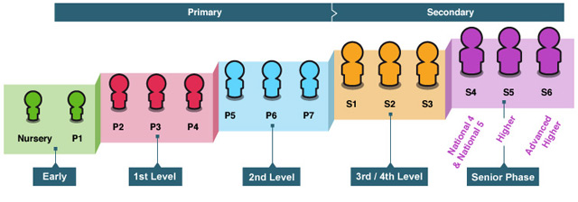
Subjects
In line with Curriculum for Excellence subjects taught are:
- Expressive Arts
- Health and Wellbeing
- Literacy and English
- Maths and Numeracy
- Religious and Moral Education
- Science
- Social studies
- Technologies

Our approach to literacy, numeracy and health and well-being

All class teachers in St. Margaret’s plan learning activities of both a discrete and cross curricular nature. Real life contexts are explored to encourage learners to develop literacy and numeracy skills and a sense of their own health and well-being.

Literacy: Active and collaborative approaches such as Literacy Circles are used to encourage competence in the key areas of literacy. Initially children learn to read and write using their phonics skills and sight vocabulary. At this stage a reading book from structured schemes is used to consolidate skills. As children progress through the school, novels and literacy circle roles are introduced. Literacy Circles encourage the children to take responsibility for their own learning by reinforcing literacy skills in a collaborative group. In some cases, novels may support the cross-curricular work of the class e.g. Flat Stanley and the Great Egyptian Grave Robbery may complement a social studies topic focussing on the Egyptians.
Primaries 1-3 use approaches from Greg Bottrill’s Can I go and Play Now? https://www.canigoandplaynow.com/
Primaries 4-7 use approaches from Talk4Writing: https://www.talk4writing.com/about/

Numeracy: A variety of resources is used to support and develop numeracy skills in St. Margaret’s and children work on independent tasks as well as in collaborative groups. The development of mental agility is a feature in all classes. ICT permeates our maths curriculum and is used regularly to enhance the learning experience. All teachers strive to create engaging lessons set-in real-life contexts so that children can make links from the classroom to the wider world. For example, in the early stages this may be achieved by setting up a shop in the classroom so that the children can learn about and use money in a real-life situation. Towards the upper stages of primary school, we would expect that children will be able to demonstrate that they are financially aware by participating in enterprising activities demonstrating their knowledge of profit and/ or loss.
Health and Well Being: Two hours of Physical Education are provided each week to all pupils. In addition to this there are a number of after school clubs providing health promoting activities. Health and Well Being lessons are planned in contexts and encourage children to examine themes such as friendship, bullying, racism etc. At times, we engage the services of other groups such as ‘Show Racism the Red Card’ or ‘I am me’ to enhance our own health and well-being programme of study. Health and Well-Being lessons are delivered in class time and at school assemblies where we aim to instil in all pupils a sense of their own health and well-being and the skills and emotions required to tolerate and understand other people as individuals too. Teachers who are qualified youth mindfulness practitioners teach mindfulness formally from P3-P7.
We are a PAThS school working in partnership with Barnardos and, as such, have been awarded SEL Worldwide Model School Status.

Our approach to relationships, sexual health and parenthood education
Sex Education is part of our Health and Well-Being and Religious Education Programmes. ‘God’s Loving Plan is used to support the learning and teaching of Sex Education throughout St. Margaret’s. This is produced by our Diocese and guidance is also provided by the Scottish Catholic Education Service.
For information on how parents can get involved with their child’s learning and with school life please follow the link to the Parents in Partnership Toolkit:

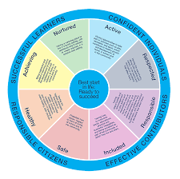
https://education.gov.scot/parentzone/Documents/parents-as-partners-toolkit.pdf

Getting it Right for Every Child (GIRFEC)
Getting it right for every child (GIRFEC) is the national approach in Scotland to improving outcomes and supporting the wellbeing of our children and young people by offering the right help at the right time from the right people. It supports them and their parent(s)/carers to work in partnership with the services that can help them.
All education staff have a statutory responsibility to promote and support the wellbeing of children and young people in their care. There are 8 wellbeing indicators and you can find out more about these here: https://www.gov.scot/policies/girfec/wellbeing-indicators-shanarri/
In St Margaret’s we have SHANARRI champions from our SHANARRI Clan. These children have worked to understand what GIRFEC means at a child’s level and they illustrate this using colours, words and symbols. Our SHANARRI Clan has designed a hall sized mural to illustrate their understanding of SHANNARI enabling the other children in our school to understand it too.

Additional Support for Learning
Renfrewshire's inclusive approach affords all children and young people the opportunity to be part of their learning community, boosting their emotional wellbeing and aiding the development of social skills. This approach is based on the core inclusive value of providing education for children within their own community as much as possible. Wellbeing assessment and individual planning is in place for all young people who require additional support.

Inclusion
Renfrewshire's inclusive approach affords all children and young people the opportunity to be part of their learning community, boosting their emotional wellbeing and aiding the development of social skills. This approach is based on the core inclusive value of providing education for children within their own community as much as possible. Wellbeing assessment and individual planning is in place for all young people who require additional support.
Support
The needs of the child or young person should always be central to the identification, planning and provision of support. Support should be appropriate, proportionate and timely.

Universal support
Universal support starts with the ethos, climate and relationships within every learning environment. It is the responsibility of all practitioners and partners.
An environment which is caring, inclusive, fair and focused on delivering learning to meet individual needs will encourage all children and young people to strive to meet their learning potential.
Personal learning planning is at the heart of supporting learning. The conversations about learning, reviewing progress and planning next steps are central to this process. Planned opportunities for achievement which focus on the learning and progress made through activities across the full range of contexts and settings in which the curriculum is experienced also contribute to the universal aspect of support. In addition, all children and young people should have frequent and regular opportunities to discuss their learning and development with an adult who knows them well and with whom they have a mutually trusting relationship. This key member of staff has the holistic overview of the child or young person’s learning and personal development.

Targeted support
Children and young people can benefit from additional or targeted support, tailored to their individual circumstances. This could be at any points of their learning journey or throughout the journey.
Barriers to learning may arise from specific learning difficulties, disability, social, emotional or behavioural needs, bereavement or family issues.
Targeted support also encompasses children and young people requiring more choices and more chances to achieve positive, sustained post-school destinations.
This 'targeted' support is usually, but not exclusively, delivered by staff with additional training and expertise.

Independent sources of information and advice nationally include -
Enquire – the Scottish advice service for additional support for learning
Telephone – 0345 123 2303
Email – info@enquire.org.uk
Resolve (Children in Scotland) - Resolve:ASL is an independent mediation service for parents and carers of children and young people with additional support needs.
Telephone – 07955 788967
Email – resolve@childreninscotland.org.uk

Educational Psychology Service
Educational Psychologists (EPs) support equity, inclusion and attainment and deliver evidence-based intervention to support pupils’ wellbeing in Renfrewshire’s schools, nurseries and other learning centres.
EPs work with teachers, parents and support staff to help children and young people make the most of their lives and support schools, nurseries and other learning centres to improve and develop supportive healthy learning environments through approaches such as the Renfrewshire Nurturing Relationships Approach, Language and Communication-Friendly Environments, Video Interaction Guidance and Non-Violent Resistance.
Our schools have a system in place for monitoring and reviewing the progress of all our young people and we have a link educational psychologist who visits on a regular basis and is part of the extended support team. When concerns are raised about a child or young person, the schools take action to address these concerns and may involve a link EP. Parental permission will always be obtained before we request to involve the link EP.

Health and Wellbeing Education
Learning in health and wellbeing ensures that children and young people develop the knowledge and understanding, skills, capabilities and attributes which they need for positive mental, emotional, social and physical wellbeing now and in the future. Learning through health and wellbeing enables children and young people to:
- make informed decisions in order to improve their mental, emotional, social and physical wellbeing
- experience challenge and enjoyment
- experience positive aspects of healthy living and activity for themselves
- apply their mental, emotional, social and physical skills to pursue a healthy lifestyle
- make a successful move to the next stage of education or work
- establish a pattern of health and wellbeing which will be sustained into adult life, and which will help to promote the health and wellbeing of the next generation of Scottish children and young people
- and, for some, perform at high levels in sport or prepare for careers within the health and leisure industries
Health and Wellbeing in schools covers:
- Mental, emotional, social and physical wellbeing
- Planning for choices and changes
- Physical education, physical activity and sport
- Food and health
- Substance misuse
- Relationships, sexual health and parenthood
Effective health and wellbeing education requires exchange of information, mutual support and collaboration with community partners, schools and parents.

Specialist support service – teachers teaching in more than one school
We have a number of teachers who work in nurseries and schools to provide specialist support to children and young people who have a range of additional support needs. These teachers work with teachers within the nursery or school to plan and deliver an appropriate curriculum. The service also provides staff development and advice on resources.
The teams support the additional needs of:
- children with a significant hearing and or visual impairment
- children with English as an additional language who are at the early stages of learning English
- care experienced children and young people and those experiencing discontinuity in their learning
- children and young people with a range of additional support needs

Homework
Homework is an integral part of learning and teaching. It provides children and young people with the opportunity to develop self-reliance, self-discipline, self-confidence and be responsible for their own learning. It also strengthens the link between home and school by supporting parents and carers to share in the learning process. Homework can take many forms and will reflect the age, stage and area of learning currently being undertaken by your child. It will be issued on a regular basis and will be varied, meaningful and interesting.
St. Margaret’s Primary School has a homework policy based on Renfrewshire Council's policy and guidance. You can request a copy of this policy from the school office.
Children are given a variety of tasks to complete at home. Reading, spelling and basic number work is most commonly given, however, research and personal projects can also be part of pupils work at home. Children can be expected to spend about 20-40 minutes, depending on age and stage, each evening from Monday to Thursday on homework. No homework should be issued for the weekend. All children have a homework diary which parents are asked to sign each night and make a comment in if they wish.

Developing the Young Workforce
Developing the Young Workforce [Determined to Succeed] is our strategy to develop the business and employability skills in young people.
It lies at the centre of curriculum for excellence and promotes a wide-range of opportunities for our children and young people aged 3-18 to become successful learners, confident individuals, responsible citizens and effective contributors.
The four main areas are:
- Enterprising learning and teaching
- Entrepreneurial learning
- Work-based vocational learning
- Career education
The themes are built around the main areas:
- Supporting the development of skills for life and skills for work
- Engaging employers
- Broadening the reach of the programme
- Embedding enterprise in the curriculum
- Building capacity
- Enhancing our international profile
Enterprising activities will be organised to reflect the age and interests of our pupils.
The range of activities can include:
- Links and partnerships with businesses, colleges, and schools abroad
- Fundraising events organised and run by pupils
- Fairtrade activities
- Joint school and community initiatives
- Work experience placements and speakers

Extra Curricular Activities
There are a variety of after-school opportunities available in St Margaret’s, most of these are sports based and delivered in partnership with Active Schools. In addition, there are some curricular opportunities including Family Learning Opportunities.

Home School Community Links

Parental Involvement
St Margaret’s Primary School has a small but willing Parent Teacher Council. It meets on a regular basis and addresses a variety of issues affecting the school community such as fundraising activities, social activities such as discos and school issues such as traffic and parking.
The PTC can be contacted by email: ptcstmargarets@gmail.com or via their Facebook page: St.MargaretsPTC
Currently, the Parent Council Chairperson position is vacant.

By law, schools have a duty to promote parents’ involvement in their child’s education and our school encourages parents to:
- be involved with their child’s education and learning
- be active participants in the life of the school
- express their views on school education generally and work in partnership with their child's schools
Every parent who has a child attending our school is automatically a member of the Parent Forum. As a member of the Parent Forum, each parent can expect to:
- receive information about the school and its activities
- hear about what partnership with parents means in our school
- be invited to be involved in ways and times that suit you
- identify issues you want the parent council to work on with the school
- be asked your opinion by the parent council on issues relating to the school and the education it provides
- work in partnership with staff
- enjoy taking part in the life of the school in whatever way possible

The Parent Forum elects a smaller group of parents to form the Parent Council. Parent Councillors may be involved in:
- supporting the work of the school
- gathering and representing parents’ views to the head teacher, education authority and Education Scotland
- promoting contact between the school, parents, pupils, and the local community
- fundraising
- organising events
- reporting to the parent forum
- being involved in the appointment of senior promoted staff
- providing a representative to the National Parent Forum of Scotland

Parent council chairs can attend the Parent Council Liaison Group, which gives parent councils an opportunity to speak with elected members and senior managers from the Council about issues relating to education in Renfrewshire. These meetings take place four times a year and details are sent to Parent council chairs at the start of each new academic year.
For more information on parental involvement or to find out about parents as partners in their child’s learning, please contact the school or visit the Parentzone website at:
https://education.gov.scot/parentzone
https://www.npfs.org.uk/

Home School Links
The Home Link Service is one of the services that supports children and families in Renfrewshire. They are a multi-disciplinary team based in different areas across Renfrewshire and linked to school clusters.
The main aim of the service is to increase the educational attainment of children and young people. This is achieved by developing links between home and school to ensure pupils identified through the school’s Extended Support Framework as facing issues at home or in school that are barriers to learning are offered additional support.
Support offered to pupils can be given individually or in a group setting. Parents are fully involved, with an initial home visit to discuss the referral and updates on progress reviewed and evaluated on a regular basis.
Support is also offered to pupils who are identified as anxious during times of change, such as moving from nursery to primary, primary to secondary and secondary to further education or employment. These can be stressful times for both pupils and parents and a Home Link Worker can support parents and the school to work together to ensure a smooth transition, and help children and young people learn how to cope with change.
Home Link is a non-statutory service and staff work in partnership with parents or carers, school staff and other agencies, including counselling and support services, health, social work and community learning and development, and other identified local voluntary and government agencies.

Pupil Council
St Margaret’s has a thriving Pupil Voice Committee and a very committed Eco Council. There is also a Reading School’s Group called the Page Turners.
The PTC also works with the Pupil Voice committee in evaluating the work of the school and in capturing the pupil’s ideas for how the school can be improved.

Community Links
The school places great importance on working in partnership with various agencies in the community to provide the most appropriate and relevant learning experiences and development for all.

School Lets
The sale and/or consumption of alcohol on school premises is prohibited. No applications for occasional licences by the school, Parent Council or other party hiring or using the school premises should be made to allow for the sale of alcohol on school premises.
To apply to use school facilities, contact OneRen. Contact details are in the important contacts section at the end of this handbook.

Other Useful Information

Listening to learn - complaints, comments and suggestions
Renfrewshire Council encourages feedback on its services from parents and pupils as part of our overall commitment to giving the best possible service and to working in partnership. We are interested in feedback of all kinds, whether it be compliments, suggestions or complaints.
If you want to register a comment of any type about the school you can do this by writing, telephoning or making an appointment to see someone. All feedback is welcome and keeps us in touch.
If, in particular, you have a complaint about the school, please let us know. It is better that these things are shared openly and resolved fairly, rather than being allowed to damage the relationship between the family and the school. There will be no negative consequences from making a complaint and we will deal with the issue confidentially. If we have made a mistake, we will apologise quickly and clearly and try to put things right.
There are some things which you should be aware of when making a complaint:
- Complaints about the school should be made first to the head teacher
- It is helpful if you can give some details of the issue and ask for an early appointment to discuss it
- We want to resolve complaints as quickly as possible. You will get a decision on your complaint in five working days or less, unless there are exceptional circumstances. If it is going to take longer than five working days, we will let you know
- If you are not happy with the response to your complaint, you have the right to take it further. You can fill in a complaints form (available from the school or any council office), fill in the online form, write to us, email us at complaints@renfrewshire.gov.uk, or call us on 0300 300 0170. At this stage, we will carry out an in-depth investigation. We will acknowledge receipt of your complaint within three working days and give you a full response within twenty working days. If the investigation is going to take longer than this, we will contact you to discuss timescales
- If you are still unhappy after the further investigation and our reply, you can take the matter up with the Scottish Public Services Ombudsman. Our reply will include the contact details
- You should also note that you have the right to raise unresolved concerns with your local councillor, MSP or MP

Data Protection
Information on pupils, parents and guardians is stored on a secure computer system and may be used for teaching, registration, assessment and other administrative purposes. The information is protected by data protection laws, including the UK General Data Protection Regulation (UK GDPR) and the Data Protection Act 2018, and can only be shared or disclosed in accordance with those laws. To find out more about how your personal information is used, please consult the Council’s general Privacy Policy, here: https://www.renfrewshire.gov.uk/article/2201/Privacy-policy
Pupils attending any type of school have a right of access to their own information by virtue of the Data Protection Act 2018. This is known as the right of subject access. When a child cannot act for themselves or the child gives permission, parents will be able to access this information on their behalf. The Pupils' Educational Records (Scotland) Regulations 2003 give parents and carers a specific right of access to their child's educational records. You can find out how to make a Subject Access Request or a request for Educational Records, by visiting the Council’s Data Protection page, here: https://www.renfrewshire.gov.uk/article/2059/Data-protection
For specific data protection queries, please contact the school directly.

Information in Emergencies
We make every effort to maintain a full educational service, but on some occasions, circumstances arise which lead to disruption. Schools may be affected by severe weather, traffic and transport disruption, power failures or fuel shortages. In such cases, we will do all we can to let you know when we are closing and reopening the school or nursery.
We use a variety of methods to keep you updated in emergency situations including: e-mails, our schools digital newsletter, text messages, the school and council websites and Renfrewshire Council's social media channels (Facebook - renfrewshirecouncil and Twitter - @RenCouncilNews).
Further information may also be provided through letters, announcements in the local press, local radio, or notices in local shops, churches and community centres.
Please ensure we have the most up-to-date emergency contact information for your family and you are following the council's social media channels. You can sign up for the school’s digital newsletter via www.renfrewshire.gov.uk/e-alerts.

Important Contacts
[schools to add to council statement]

Director of Children’s Services

Steven Quinn | Renfrewshire House  Cotton Street  Paisley  PA1 1LE | Email  csdirector@renfrewshire.gov.uk  Phone: 0141 618 6839
Homelink Service Senior Home Link Workers

 | c/o West Primary School  Newton Street  Paisley  PA1 2RL | Email  morag.mcguire@renfrewshire.gov.uk  pamela.mckechan@renfrewshire.gov.uk Phone: 0300 300 1415
Community Learning & Development

Community Facilities Section | OneRen  3rd Floor  Renfrewshire House  Cotton Street  Paisley  PA1 1LE | Email  comfac@renfrewshire.gov.uk  Phone: 0300 300 1430
Adult Learning Services | West Johnstone Shared Campus  Beith Road  Johnstone  PA5 0BB | Email  als.els@renfrewshire.gov.uk  Phone: 01505 382863
Youth Services | West Primary School  Newton Street  Paisley  PA1 2RL | Email  youth@renfrewshire.gov.uk  Phone: 0141 889 1110
Customer Service Centre

Customer Service  Centre | Renfrewshire House  Cotton Street  Paisley  PA1 1AN | Email  customerservices.contact@renfrewshire.gov.uk  Phone: 0300 300 0300

Websites
You may find the following websites useful.
- https://education.gov.scot/parentzone/ - parents can find out about everything from school term dates to exam results. This site also offers information for nursery aged children and young people who have left school. It also lists relevant publications for parents and provides hyperlinks to other useful organisations
- https://education.gov.scot/education-scotland/inspection-reports/ - parents can access school and local authority inspection reports and find out more about the work of Education Scotland
- https://education.gov.scot/parentzone/find-a-school - parents can find out about individual schools. They can choose a school and select what type of information they need such as Education Scotland reports, exam results, stay on rates and free school meal entitlement
- http://www.renfrewshire.gov.uk/ - contains information for parents and information on Renfrewshire schools
- http://www.childline.org.uk/Explore/Bullying/Pages/Bullyinginfo.aspx - contains information for parents and children on varying forms of bullying and provides help for parents and children who are affected by bullying
- http://www.respectme.org.uk/ - Scotland’s anti-bullying service. Contains information for parents and children on varying forms of bullying and provides help for parents and children who are affected by bullying
- https://education.gov.scot/- provides information and advice for parents as well as support and resources for education in Scotland
- http://www.equalityhumanrights.com/ - contains information for everyone on equality laws within the government and local authorities

Glossary
ASL – Additional Support for Learning
ASN – Additional Support Needs
CFE - Curriculum for Excellence
CLAD – Community Learning and Development
FOI – Freedom of Information
GIRFEC – Getting it Right for Every Child
HT/PT/PST – Head Teacher/Principal Teacher/Pastoral Support Teacher
LTS – Learning and Teaching Scotland
SIP – Service Improvement Plan

Although this information is correct at time of publishing, there could be changes affecting any of the contents before or during the course of the school year or in future school years.

Parent feedback
Please take a few minutes to fill in and return the questionnaire on the next page. Your feedback will help us improve the handbook next year.

Tell us what you think
Your feedback will help us to improve our handbook.
Did you find Please tick
1. the handbook useful? ◻Yes ◻No
2. the information you expected? ◻Yes ◻No
3. the handbook easy to use? ◻Yes ◻No
Please tell us how we can improve the handbook next year.

Name of school:______________________________________
Thank you for filling in the questionnaire. Your views are appreciated. Please return this questionnaire to:
Policy & Commissioning Team
Children’s Services, Renfrewshire Council
Renfrewshire House
Cotton Street
Paisley
PA1 1LE
email address: csdatapolicy@renfrewshire.gov.uk

